



**SM6P07NI Digital Media Project**

**20% Research and Proposal**

**2024-25 Autumn**

**Student Name: Anupam Sigdel**

**London Met ID: 22067426**

**College ID: NP01MM4A220102**

**External Supervisor: Pooja Shrestha**

**Internal Supervisor: Rakshak Bhusan Bajracharya**

**Assignment Due Date: 8th January 2025.**

**Assignment Submission Date: 7th January 2025.**

**Word Count: 2811**

*I confirm that I understand my coursework needs to be submitted online via Google Classroom under the relevant module page before the deadline in order for my assignment to be accepted and marked. I am fully aware that late submissions will be treated as non-submission and a marks of zero will be awarded.*

Abstract

This project explores the process of optimization of the 3d mesh for game environments, focusing on the real time rendering, topology optimization and environment modelling through Autodesk Maya and texturing through Adobe Substance Painter. The project focuses on the creating detailed 3d environment with reduced polycount, baking textures and using (LOD) system. It reviews games like counter strike and call of duty to study technique like PBR rendering and reusable assets. The project aims to provide understanding into balancing high quality visual with performance efficiency models and environment.

**Table of Contents**

1 Section A: Research 2

1 Introduction 2

2 Literature Review 3

2.1 Story telling 3

2.2 Game topology 4

2.3 Real-Time Rendering 5

2.4 Challenges in Topology optimization 6

3 Product Review 7

3.1 Counter – Strike 7

3.2 Call of duty 8

3.3 Valorant 10

2 Summary and Conclusions 12

4 Section B: Project Proposal 13

1 Project Title 13

2 Research Question 14

3 Treatment 15

4 Resources 16

5 Contribution of Others 17

6 Evaluation & Testing 18

5 References 19

6 Bibliography 20

7 Appendix 21

**Table of Figures**

Figure 1: Storytelling 3

Figure 2: Normal and Optimized topology 4

Figure 3: real time Rendering 5

Figure 4: Bad and Good topology 6

Figure 5: Counter strike environment 8

Figure 6: call of duty 9

Figure 7: Valorant environment 11

# Section A: Research

## Introduction

The upcoming project primarily focuses on exploring on the topic of how meshes are optimized for the games by using tools and 3d software. Game development is increasingly being relied on the efficiency and performance of the processor. The aim of the project is to create a detailed 3d environment while ensuring optimization for real time application and rendering.

This project will utilize Maya and Adobe Substance painter to model and texture the environment to create detailed and visually appealing assets. It will use methods and techniques like reducing the polycount, baking of mesh from high poly to low poly by baking textures and implementing level of detail (LOD) systems to balance visual detail and performance.

The goal of this project is to provide insights into creating efficient, high quality game environments with use of as less polygon as possible. Ultimately, it shows the importance of balancing visually appealing detail with performance friendly environment and optimized for different hardware platforms.

# Literature Review

When creating environment for game there are many theories and experiments. When crafting an environment whether it is realistic or stylized designer puts a lot of though and theories into it.

## Story telling

The first thing while modelling any type of environment for the game is the story telling. This approach of modelling help players to immerse themselves into the game and be a part of it. While these games are heavily focused on the combat and strategy use of visual details such as damaged buildings and graffiti helps to convey the messages to the player about the environment as it suggests chaos and war. This technique helps players to feel more connected to the environment they are playing. Designers achieve it carefully placing some slogans or some NPC as well as some object in the environment that may hint at how the world operates inside the game, making it easier for players to connect with the game.

Storytelling through game map can be fine but it is very effective in the long run as it enhances the player’s experience without disturbing the overall game play

(AI, Generated image 2024)

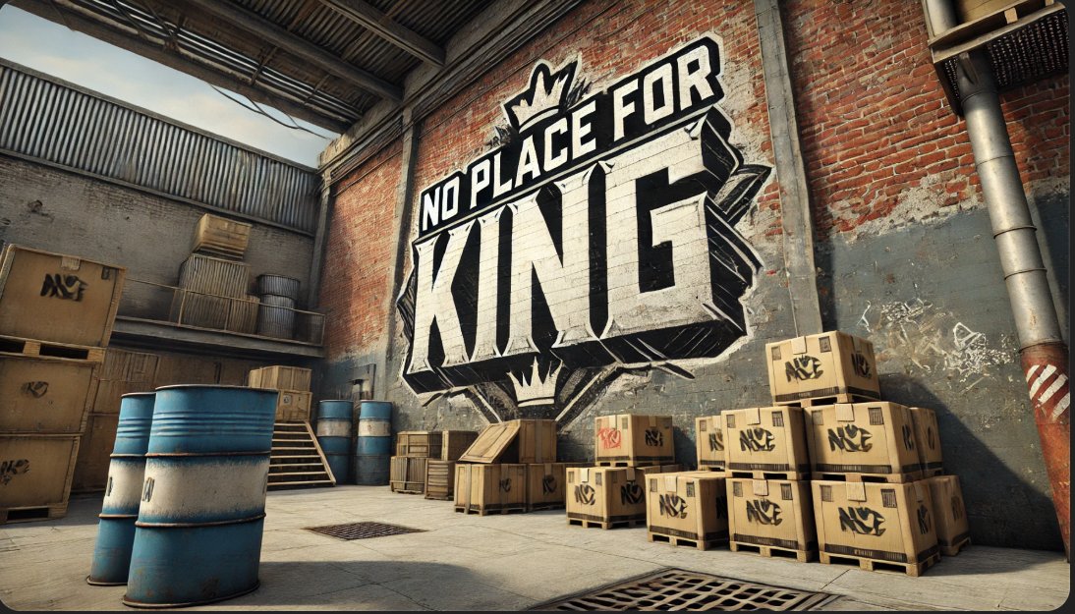

Figure 1: Storytelling

## Game topology

One of the most important things to remember while making models and props for the game is the proper optimized topology. Game topology usually means that we must get as much detail as possible with as low poly count as possible. Lower the poly count the smoother the game will be. When we lose polycount it becomes difficult to capture all the detail of the model. In that time, we use texturing for the detail capture. It is very important for game to have as low topology as possible as it will take less time to render, and game will be more efficient. Game topology also depends on the type of assets that we are dealing with. For example, when it comes to building and other models that won’t be animated in the production, we can minimize the polygon and keep clean geometry. Poorly designed model with unnecessary complex topology can result in less optimized game and poor experience for the user.

Some of the software like unreal and Maya support (LOD) systems in which the high-resolution version of the mesh can be replaced by the low-resolution mesh at a distance so it can be modelled in low poly count

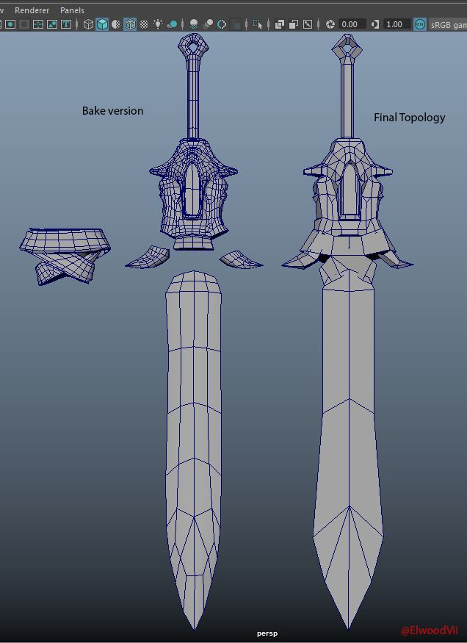

Figure 2: Normal and Optimized topology

Here in the above example, we can see the topology of normal model and on the other side we can see the optimized version that can be used for game

## Real-Time Rendering

Real-Time rendering is very important when it comes to game. Everything in the game needs to be rendered the moment it is visible in the camera. For this to happen, the assets of the game need to be very optimized and likely needs to be low poly or else game might get slow and it might give bad experience to the user. There are many ways to achieve real time rendering. It is less expensive than rendering all the data of the game always even when it is not displayed on the camera. Normal Maps and baked textures are widely used to achieve this optimization. Real time rendering generates the frames instantly as the player interacts with the environment of the game. Only those object that are In the view of camera are rendered so there is less strain on the processor. To make the real time rendering more optimized high poly version of models are replace with the low poly version of the model when models are far from the camera. As previously mentioned, normal map and diffuse map with now a days also the PBR based rendering is used to give a better looking environment. Shaders are also optimized to render the material efficiently

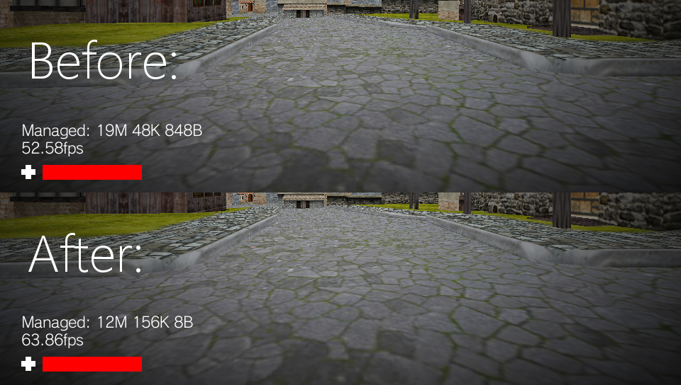

Figure 3: real time Rendering

## Challenges in Topology optimization

When it comes to optimization of topology for animated game characters designer must keep deformation in mind. One of the most difficult things in topology optimization is to not affect the deformation of mesh despite reducing the number of polygons in the mesh. Models that are not optimized properly can cause problem later in the pipeline.

Improper topology optimization can create problems like improper deformation of mesh or clipping. This kind of issue can be very difficult and time consuming and it takes a lot of time to fix which increases the time in production making the production more expensive. By focusing on creating clean topology, artist can make sure that the character are functional for the animation process

Another challenge in optimization of topology for environment is the use of material and texture mapping for the environment and assets. If number of polygons is reduced too much then the texture that was originally made for the high poly version of the mesh may not be applicable for the low poly version of the mesh which was made after retopology and at that time baking of texture might not work. Moreover, the environmental assets often requires complex texture setups due to variation in the surface such as wall, floor and props which must be mapped properly for consistency

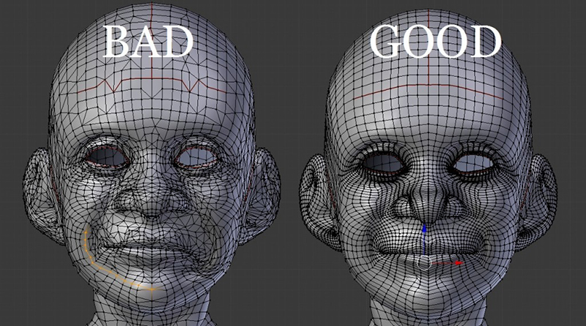

Figure 4: Bad and Good topology

# Product Review

The game environment is that I am going to model is inspired by the games like call of duty and counter - strike, based on that the environment will be semi- realistic.

## Counter – Strike

1. The environment of Counter-Strike looks semi-realistic due to excellent use of textures and object scale.
2. Many reusable assets, including barrels and barriers, are found in the map.
3. The game is optimized, with perfect topology and excellent use of normal maps and baked textures.
4. All weapons and buildings have clean topology and very low poly count, aiding real-time rendering.
5. CS:GO stands as an excellent example and case study for any artist.

**Pros**

1. Some of the maps of the counter strike have realistic design standard which helps for visually appealing and functional gameplay
2. It has got interactive environments such as breakable props which makes it very player friendly
3. It teaches us the performance driven design for smooth and fast paced gameplay across much hardwares.
4. Since it is online multiplayer, game can be played again and again.

**Cons**

1. Many of the texture in the game are repeated which can make it seem repetitive
2. Just like the texture many of the building are also repeated which can also make the architecture repetitive
3. There is lack of atmospheric elements like dynamic weather in the game
4. Since it follows more realism theme the colour palette used for the game is restricted to dull colour to simulate the realife

Figure 5: Counter strike environment

## Call of duty

1. Call of Duty is a benchmark for first-person shooting games with high-detail assets and immersive environments.
2. The game uses low-poly and optimized poly counts, mainly for weapons and characters.
3. Unlike Counterstrike, it emphasizes high-end textures, utilizing PBR materials for realistic surfaces.
4. Call of Duty focuses more on large-scale environment building.
5. It extensively uses modular buildings to reduce artist workload and maintain clean workflows.

**Pros**

1. Call of duty utilizes PBR based rendering and ray tracing in the game so it gives realistic lighting
2. Game does a very good job in conveying the story with the help of props and assets
3. Unlike counter strike call of duty has a large variety of props include some unique and some reusable props
4. Like props there is also a large variety of building in the game which makes it less repetitive

**Cons**

1. It has hyper detailed assets and environment, so it requires more time, tools and technical expertise.
2. There are some high polygon assets despite being a game so it can be a technical challenge during performance maintenance
3. There are some physics simulations that can be found which can create challenge for maintaining performance
4. Since it is based around the fast paced gameplay players often overlook complex detail so the artist talent may be ignored

Figure 6: call of duty

## Valorant

1. The valorant game has the balance use of realistic proportions with vibrant and clean designs.
2. Maps are designed with distinct colour schemes and has clear shapes which the artist focus on making it functional and easy for plyers to understand.
3. Each map has its own unique theme which offers variety while still fitting into the game world
4. Environment are designed for competitive play using simple model and detailed textures
5. Although with great visuals on maps it does not include strong storytelling which can feel limiting to the artist who tend to add narration in their game.

Pros:

* Valorant being a first perspective game has a combination of vibrant style and realism.
* The navigation and the design principles help the user to guide through the game in a easy way.
* Maps and characters used in the game are bold and use contrast colours that enhance the clarity
* Lighting is designed in such a way that it highlights the overall area and the key area of the game.
* The maps have a stye of unique storytelling which adds the narrative details into the environment design

Cons:

* The materials used in the design lack details which may seem to be not appealing to the user.
* The props used in the game design ae used frequently. This shows how the variety of design has limitation to the game
* The static design of the game feels less engaging to the users
* The lack of dynamic and moving elements in the background makes the environment feel less alive
* Areas outside the gameplay zone feel to be underdeveloped to the users.

Figure 7: Valorant environment

## Summary and Conclusions

This document outlines a proposal of the project focused on the optimization of 3d meshes for the game environment using different software like substance painter and Autodesk maya. It focuses on more on achieving high level quality visual with help of as low polycount as possible. More focus on the texture baking part and level of detail (LOD)systems. The projects aims to make semi realistic shooting game like counter strike, call of duty and valorant in the theme of an office named ‘Corporate Crossfire.’ The research highlights storytelling aspect along with the topology optimization and real time rendering and thigs like the challenges that might appear while baking and texturing process.

# Section B: Project Proposal

## Project Title

Project Title: Corporate Crossfire

This project aims to create environment for shooting game that is set in an office environment inspired by the game like call of duty and counter strike. Office themes include cubicle rooms, meeting rooms and break area with props like sofa and chair. The project emphasis strategic teamwork and creative use of the environment for cover.

## Research Question

**How is 3d mesh optimized for the game?**

Optimization of the 3d mesh is very necessary and standard for the industry. To optimize the mesh, we start by reducing the number of the polygon. Artist still must maintain the shape and geometry of model. We can reduce the number of polygons by deleting the unnecessary geometry like faces and edge also in some cases bevel edges and instead use crease on those edges. We still need to have details on the mesh so instead of using the model with high poly for more detail we first bake the high poly and reduce the number of polygons of high poly and making it low poly and then projecting the texture of high poly mesh into low poly mesh. Artists must keep in mind that for the baking of textures low poly mesh must have proper UV for it to keep the similar textures from the high poly.

Artist also uses the technique like optimizing the topology of the mesh by localising topology, using triangles where deformation is not needed and avoiding the n-gons. In some of the game we have seen that there is prebaked lighting on some of the model to reduce the load on GPU. In some software’s like Zbrush there are tools such as decimation which directly reduces the number of polygons without reducing the detail, in other software’s like maya and blender there is option of retopology which helps to streamline the process.

## Treatment

Target Audience:

Interest: competitive gamers who enjoy the skill-based game.

Age: There will be some violent element like gun 16 – 35 ages.

Demographic:

Gender: mostly targeted towards males but females can play it too.

Geography: all around the globe because the concept will be familiar and as it is inspired from well-known game.

User experience: Players can feel really connected as the game will require a lot of focus and strategy and teamwork. Player can also feel some challenge as they will be playing against other real human with almost same amount of experience

## Resources

**Technology of choice**

Platform: PC (windows)

Software Used: Autodesk maya: for 3d modelling, rendering, UV mapping)

Substance Painter (Texturing)

Photoshop (2D texture)

**Resources needed**

Hardware: ASUS ROG G16 (3060 ti) (1TB)

Software: Autodesk maya, Substance Painter, Photoshop

**Production skill:** Modelling, Texturing, Optimizing, Lighting

Research: Maps from Call of Duty and CS: GO

**Gantt chart**

## Contribution of Others

Some of the website like turbosquid, sketchfab, official website of call of duty and valorant was taken in consideration for the topic ad subject matter.

Some 3d creator like Abe Leal 3d, flipped normal, Cryptic visionary has helped during the initial phase of the project

## Evaluation & Testing

A survey will be conducted to get the response from the public. Changes will be made in the environment by looking at the response of the public

First party evaluation of the project was done by the supervisors: External supervisor and internal supervisor

Test the model will be done in the Ureal Engine software.

The optimization of the model will be tested by looking at the polycount

# References

# Bibliography

# Appendix